Snap Shot of the Project

1 . ) Home Panel Image

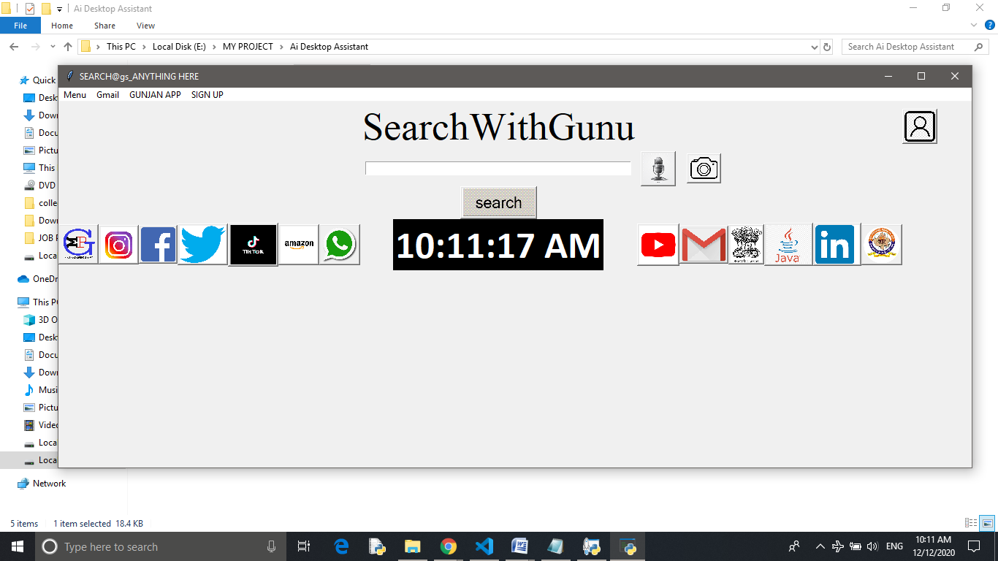

2 . Login Panel image for inserting data into the sqlite3 database

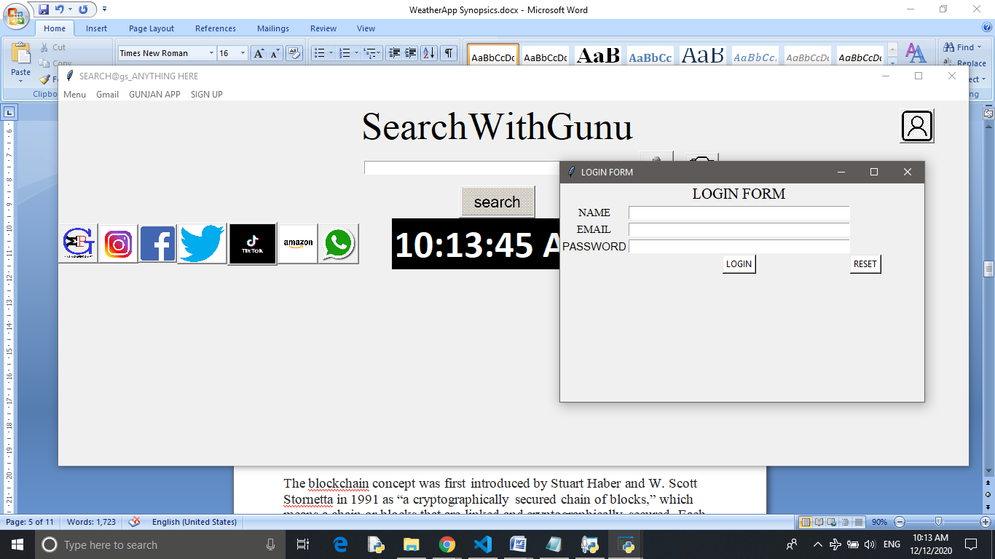

3. Menu bar and external tools for the tool interactions with user

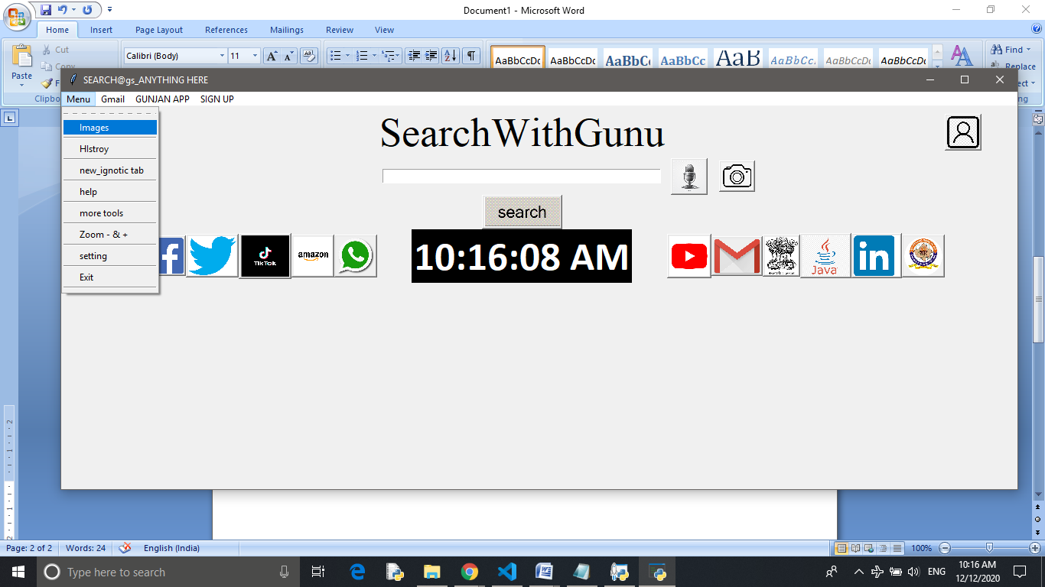

4. search like the google and other search engines procedure

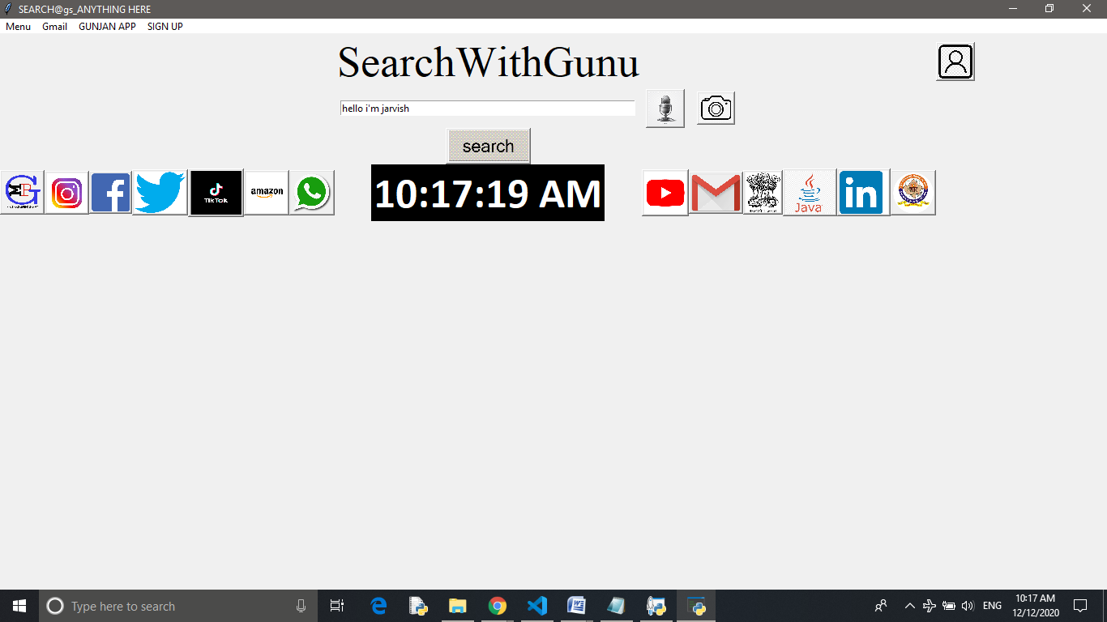

1. After searching this will work like the

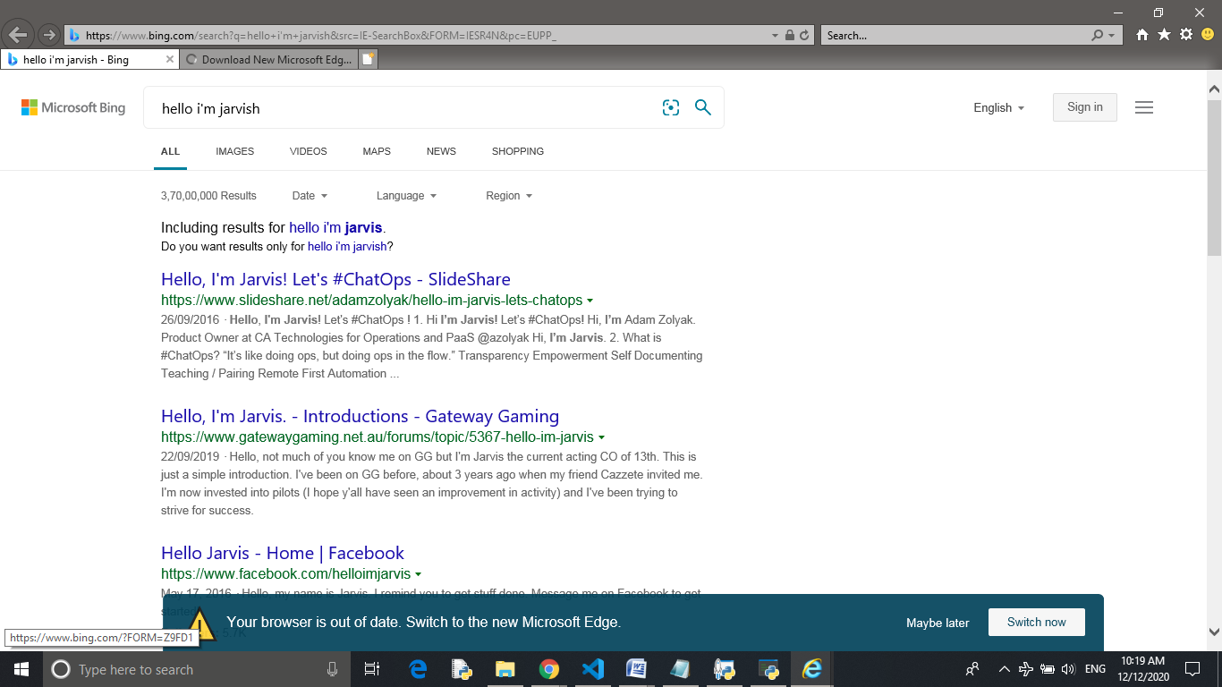

5 . After using the voice Reorganization system in this app , at the system end it will handle this like :

